Programming Fundamentals – Lab Session 03 (37607)
Question 01
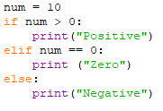
Question 02
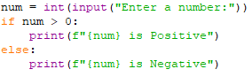
Question 03
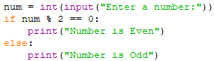
Question 04
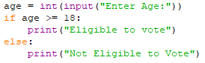
Question 05
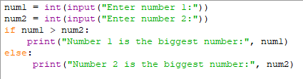
Question 06
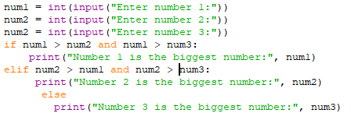
Question 08
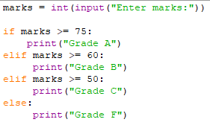
Question 10
